Nathan Bemus

Digital Image Processing

ECCS 4361

9/13/17

Task 1:

This is the image that has the low brightness and bad contrast.

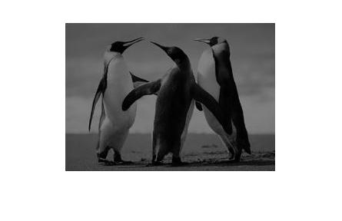 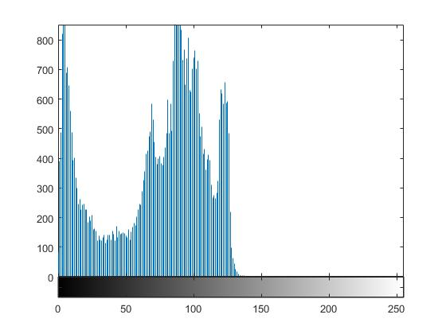

The following Matlab code was used to find both the mean and standard deviation of the image.

std(std(double(I)));

imshow(I);

mean(mean(double(I)));

std(std(double(I)));

S = std(std(double(I)));

M = mean(mean(double(I)));

imhist(I);

histeq(I);

figure(2), imshow(I);

This is the image after the Matlab code.

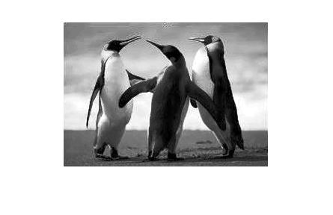 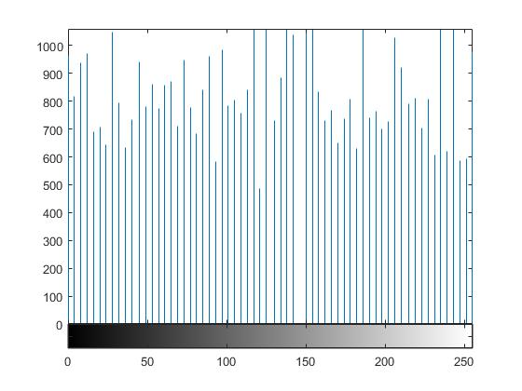

>> im = imread('Grayscale Penguin', 'jpg');

>> im=rgb2gray(im);

>> x = std(std(double(im)));

>> y = mean(mean(double(im)));

>> steps = (0:1:255);

>> z = (1 ./ (sqrt(2 .\* pi) .\* x )) .\* exp(-0.5 .\* ((steps - y) ./ x) .^ 2);

>> im2 = histeq(im, z);

Task 2:

imMatrix =zeros (495, 765);

imMatrix(166:330 , 256:510) = im;

imMatrix(166:330 , 511:765) = im(165:-1:1 , 1:255);

imMatrix(166:330 , 511:765) = im(1:165 , 255:-1:1);

imshow(imMatrix);

>> imMatrix(166:330 , 1:255) = im(1:165 , 255:-1:1);

>> imshow(imMatrix);

>> imMatrix(1:255 , :) = im(165:-1:1 , 1:255);

Subscripted assignment dimension mismatch.

>> imMatrix(1:255 , :) = imMatrix(310:-1:166 , :);

Subscripted assignment dimension mismatch.

>> imMatrix(1:165 , :) = imMatrix(310:-1:166 , :);

Subscripted assignment dimension mismatch.

>> imMatrix(1:165 , :) = imMatrix(330:-1:166 , :);

>> imshow(imMatrix);

>> imMatrix(331:765 , :) = imMatrix(330:-1:166 , :);

Subscripted assignment dimension mismatch.

>> imMatrix(331:495 , :) = imMatrix(330:-1:166 , :);

>> imshow(imMatrix);

>> imshow(imMatrix/max(max(imMatrix)),[0,1]);